# Assignment - II

# Name : M.Kannan

# Roll No : 17UN**25**

# Class : III B.Sc. CS ‘B’

# Subject Name : Data Mining

# Subject Code : S5E01

# Topic : Applications of Cluster

# Submitted To : P.PandiSelvam M.Phil.

# Submitted On : 26/9/2019

# APPLICATIONS OF CLUSTERING

# Applications of clustering:

Where clustering is been applied in various fields were some of the applications are:

# Use of Clustering in Data Mining:

Clustering is often one of the first steps in data mining analysis. It identifies groups of related records that can be used as a starting point for exploring further relationships.

* This technique supports the development of population segmentation models, such as demographic-based customer segmentation.

Additional analyses using standard analytical and other data mining techniques can determine the characteristics of these segments with respect to some desired outcome.

* For example, the buying habits of multiple population segments might be compared to determine which segments to target for a new sales campaign.
* For example, a company that sales a variety of products may need to know about the sale of all of their products in order to check that what product is giving extensive sale and which is lacking. This is done by data mining techniques.

But if the system clusters the products that are giving less sale then only the cluster of such products would have to be checked rather than comparing the sales value of all the products.

This is actually to facilitate the mining process.

# Application of Clustering in Text Mining:

Text mining, also referred to as text data mining, roughly equivalent to text analytics, refers to the process of deriving high-quality information from text. High-quality information is typically derived through the devising of patterns and trends through means such as statistical pattern learning.

Text mining usually involves the process of structuring the input text (usually parsing, along with the addition of some derived linguistic features and the removal of others, and subsequent insertion into a database), deriving patterns within the structured data, and finally evaluation and interpretation of the output.

* 'High quality' in text mining usually refers to some combination of relevance, novelty, and interestingness.
* Typical text mining tasks include text categorization, text clustering, concept/entity extraction, production of granular taxonomies, sentiment analysis, document summarization, and entity relation modeling

Text mining consists of extraction information from hidden patterns in large text-data collections

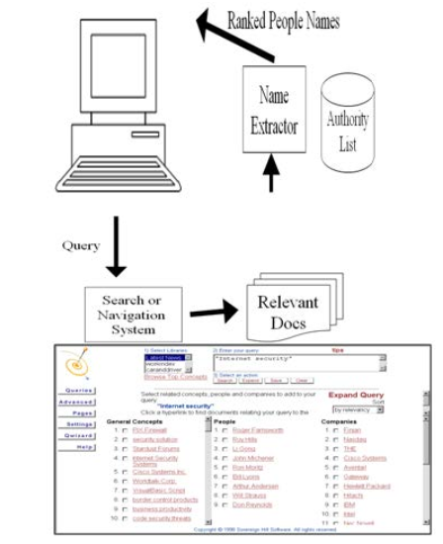

Fig:1

The query is given in the system were the given query is been founded by using the search navigation system. Where the documents based on query search is been given here in the diagram.

Where is been extracted using name extractor. From the authorization list the ranking details are viewed on it.

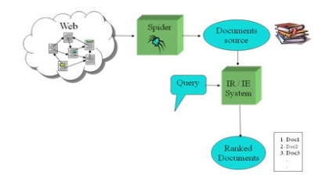

Fig 2: Working of Cluster in the Search Engines

# Some other Applications of Clustering:

Where the clustering is been used in Fields of applications on it

* Data Mining
* Pattern recognition
* Image analysis
* Bioinformatics
* Machine Learning
* Voice mining
* Image processing
* Text mining
* Web cluster engines
* Whether report analysis